John Romaine C. Cagubcub  
BCS41

Activity 1 Python Multithreading count to 10

CODE

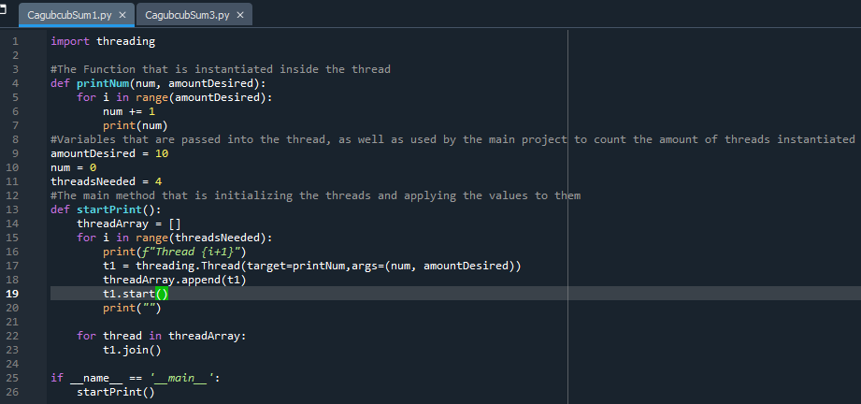

Output

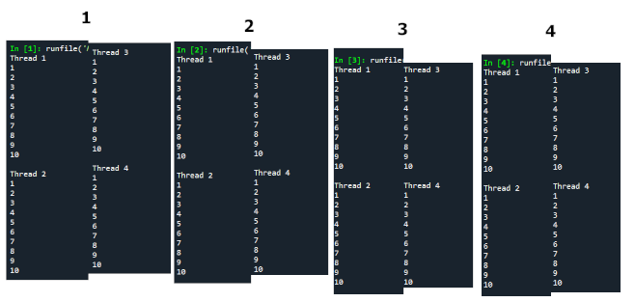

Activity 2 Java Sequential and Parallel Stream Counting

Code

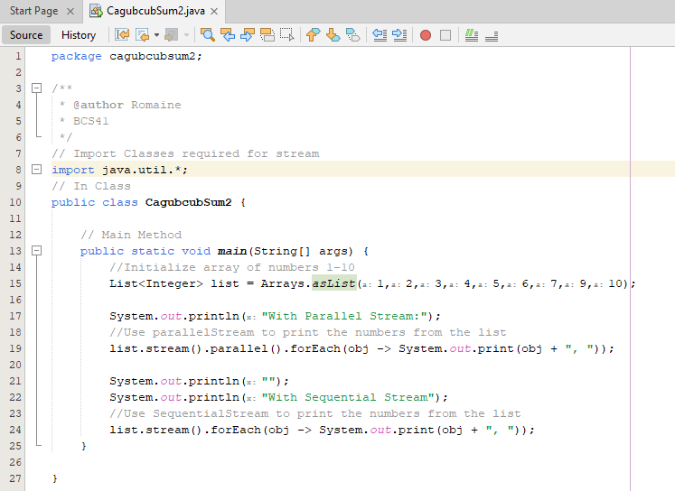

Ouput

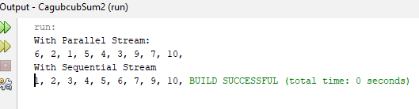

Activity 3 Conways Game of Life with Multithreading

Code  
Part 1  
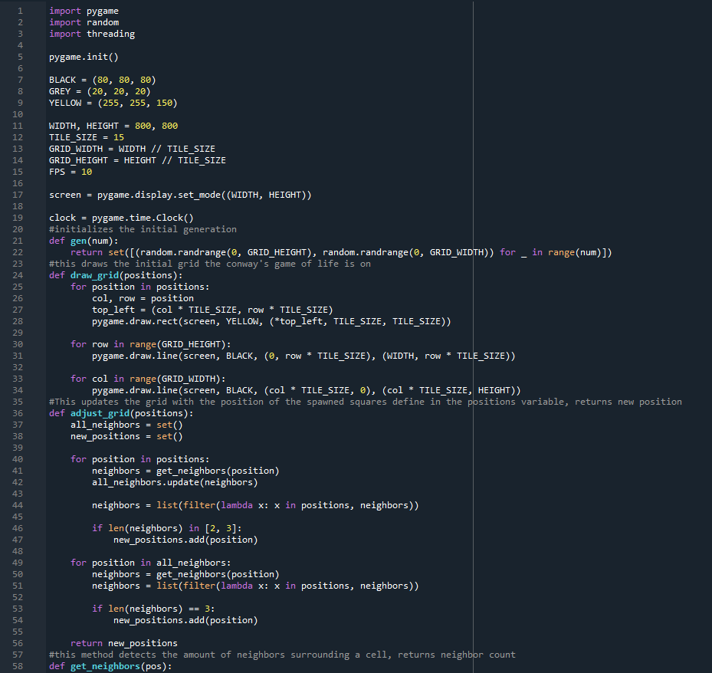

Line 5 to 17 are all variables and objects that will be used in the program.  
Pygame will be the method used to display the program. (Pip plugin pygame needed)  
the “gen” function dictates the initial generation to be spawned, referenced later in the main game method  
draw grid is the script that draws and redraws the grid’s content  
adjust grid is the method that adjusts the cells to be drawn on based of the value get neighbors function returns

Part 2  
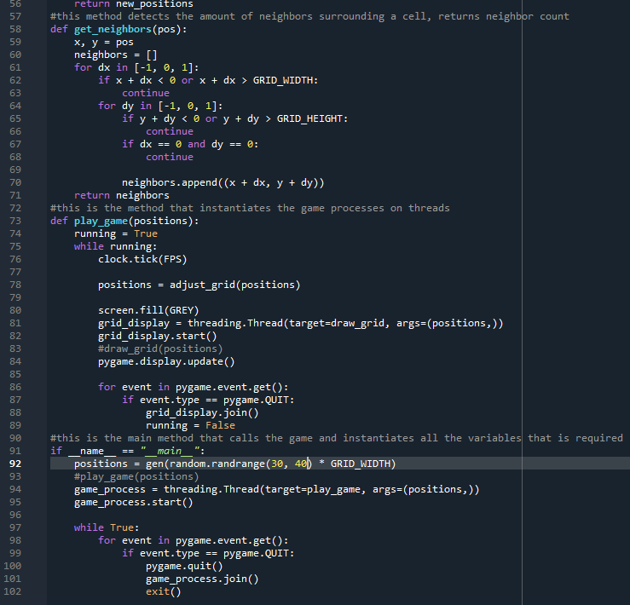

Get neighbors method searches the surroundings of the center cell and determing whether there are any nearby cells, returns a value depending on the cells detected  
Play_game method is where all the variables and methods are called, the speed the game runs on is initialized in the clock tick method, the positions variable are constantly updated by the return value of adjust_grid, then based off these values on threads the visual updates are processed by the grid_display thread.  
on the main method, the initial positions is defined, and the game_process is started which is a thread that initializes the game and runs it.  
The final method is just a check to see whether the user exits the game, this will join all running threads and exit the conway’s game of life simulation

SCREENSHOTS  
